Date :01/02/23 Seat No:

…………………………………………………......

**PRACTICAL NO.4**

**Aim:** **Working with attributes**

1) Start a new project.

Go to Layer 🡪Add Layer 🡪Add Vector Layer Select“\GIS_Workshop\Practicals\Practical_04\A\Data\ne_10m_populated_places_simple.zip”

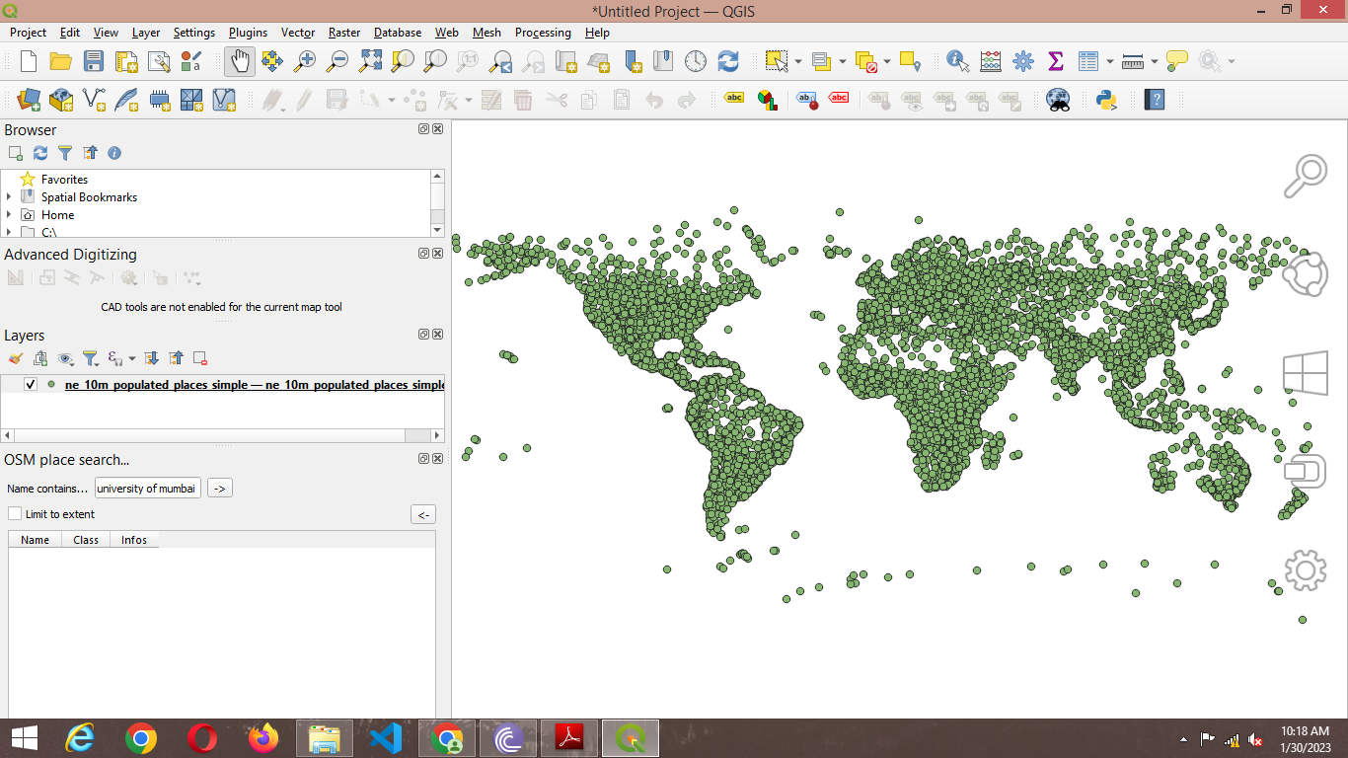

2) Right click on Layer in Layer Panel → Open Attribute Table.

Explore various attributes and their values in the Attribute table.

To find the Place with maximum population click on “**pop_max”** file .

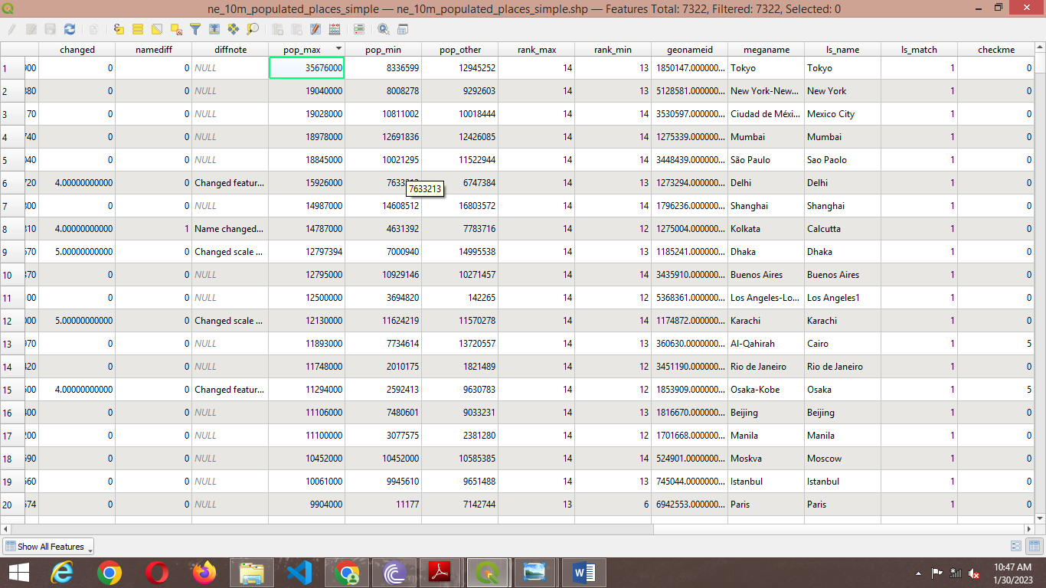

3) On clicking the Select feature using expression  button the following window will appear.

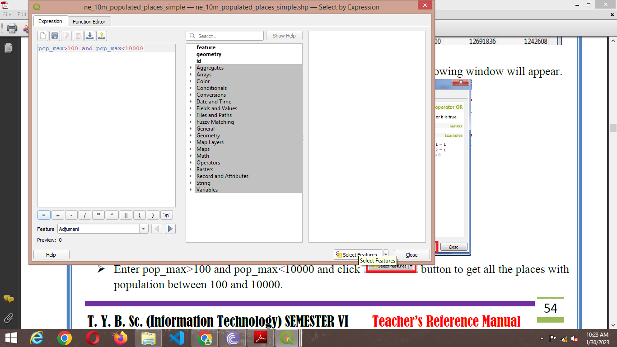

4) Enter pop_max>100 and pop_max<10000 and click  button to get all the places with population between 100 and 10000

5) The places matching the criteria will appear in different color.

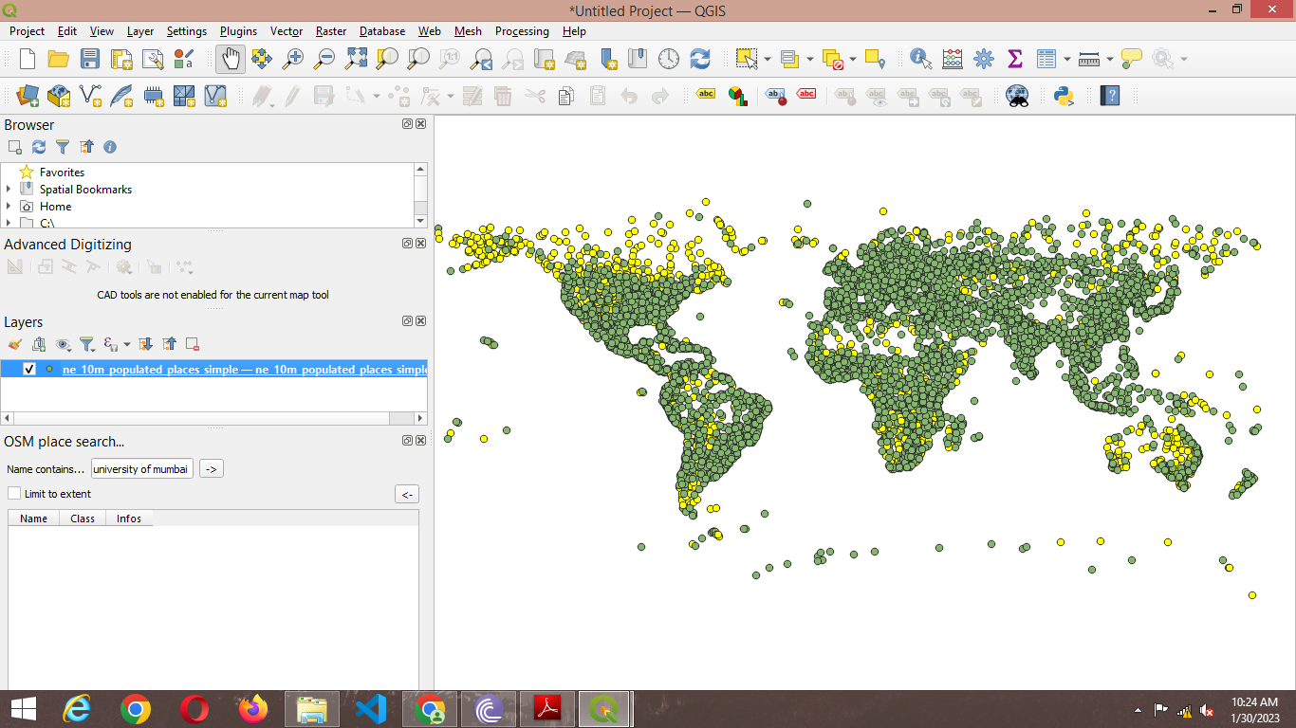

6) Different queries can be performed using the dataset

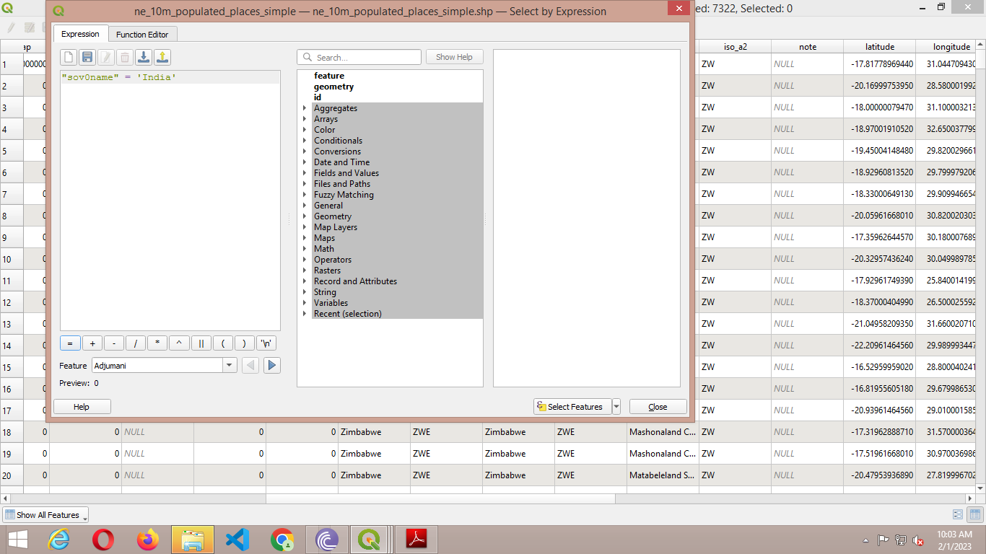

Will give

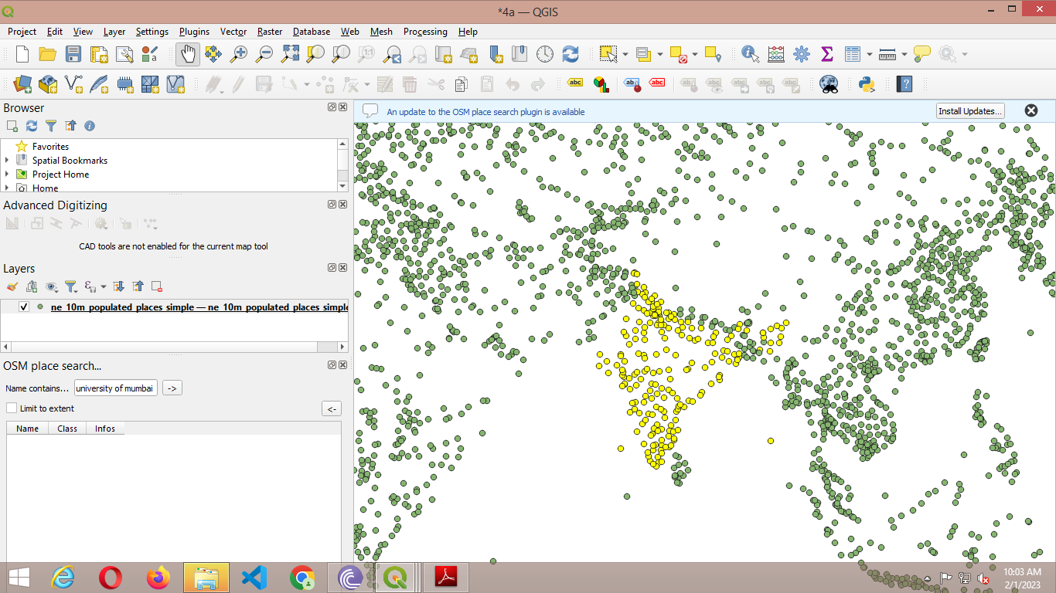

7) Use the deselect button  to deselect the feature to be rendered in original color.

**b) Terrain Data and Hill shade analysis**

1. Go to Layer → Add Raster Layer → select “10n060e_20101117_gmted_mea300.tif”, from Data folder.

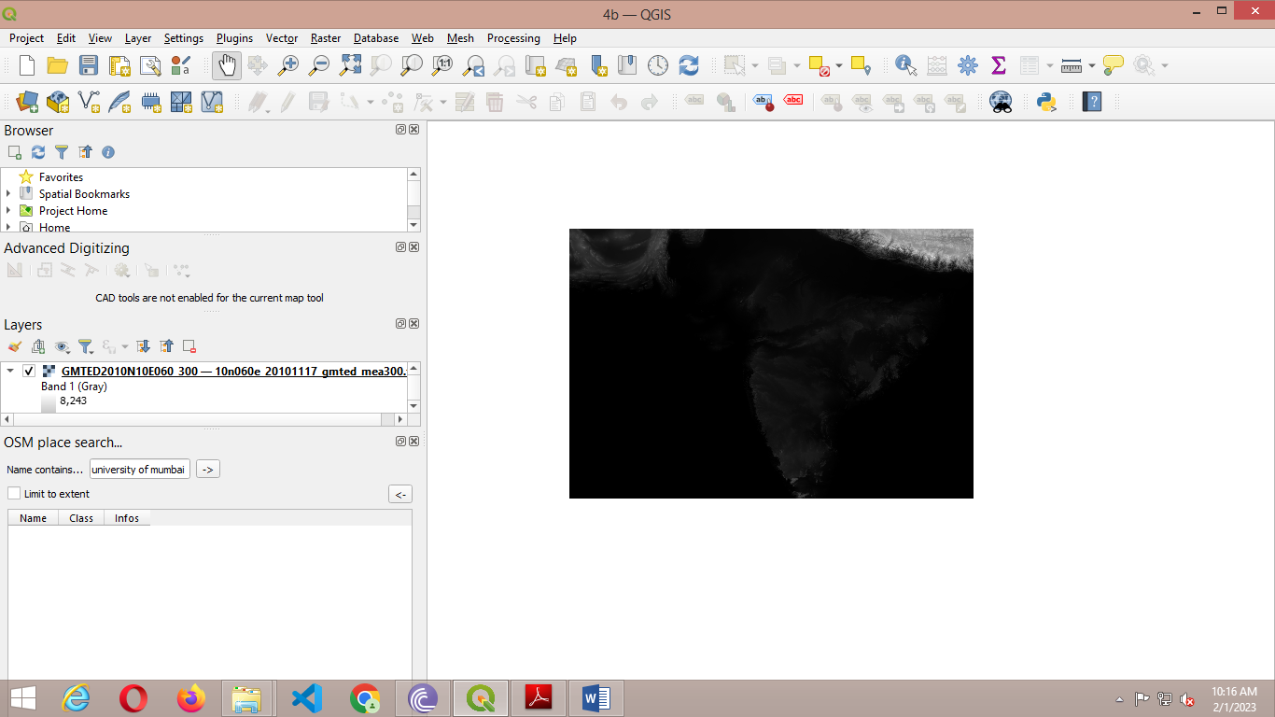



2) Enter 86.92, 27.98 in the coordinate field, Scale 900000 and Magnifier 100% at the bottom of QGIS.

Press enter the view port will be centered on Himalaya Region

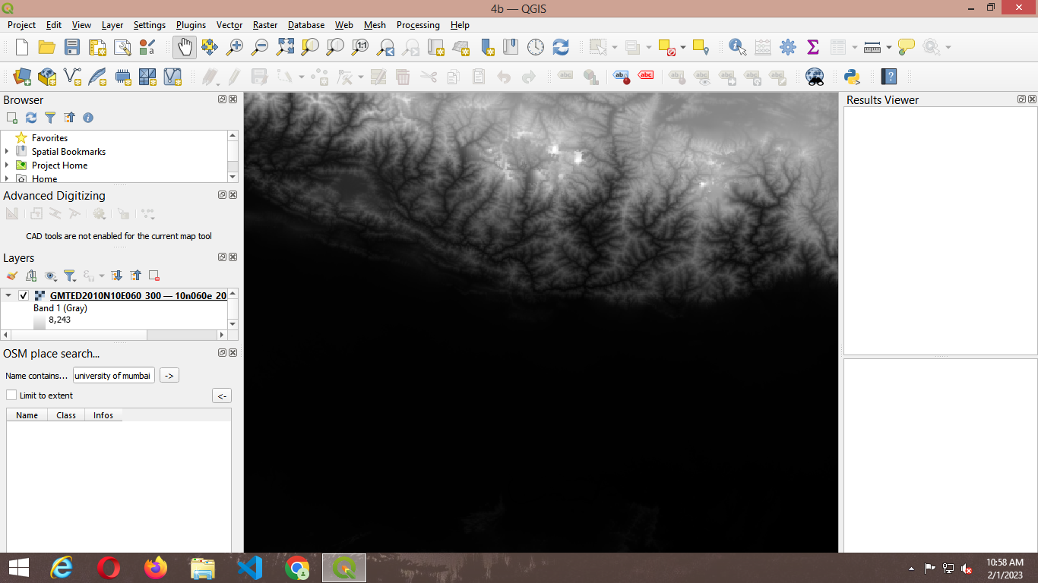

3) Crop the raster layer only for the region under study.

➢ Go to Raster → Extraction→ Clip Raster by Extent

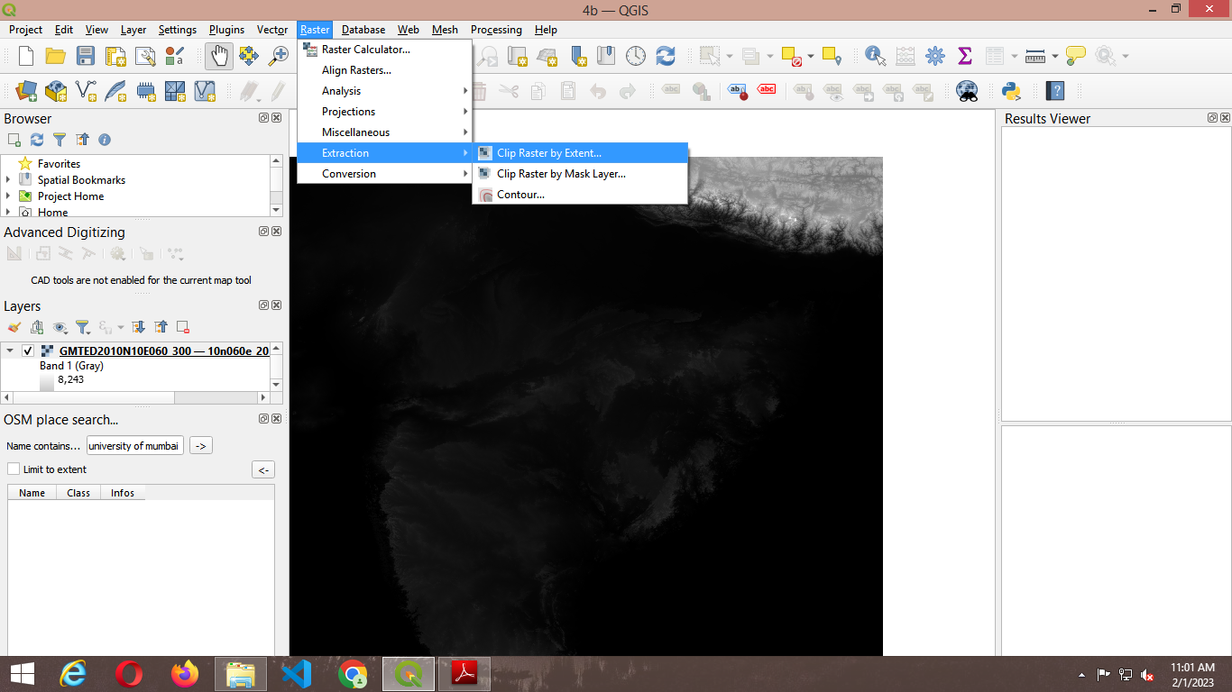

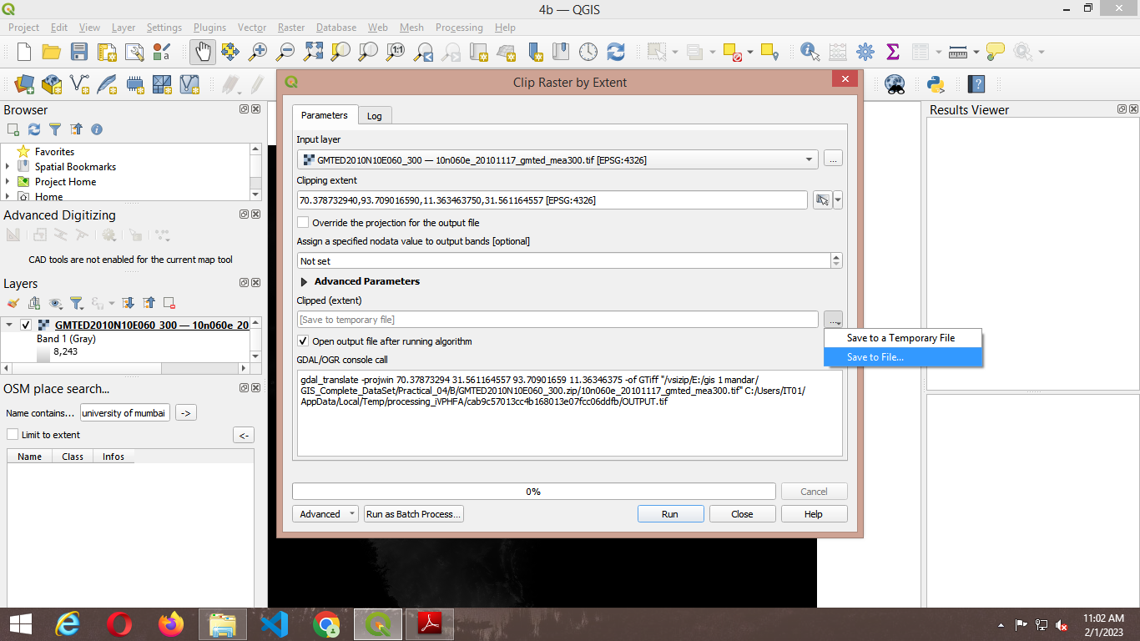

4) Select the clipping area by selecting the option **Use Canvas Extends** if the visible part of map is to be selected or manually select an area on canvas by using **Select Extent on Canvas**.

Select the location and file name for storing clipped raster layer.

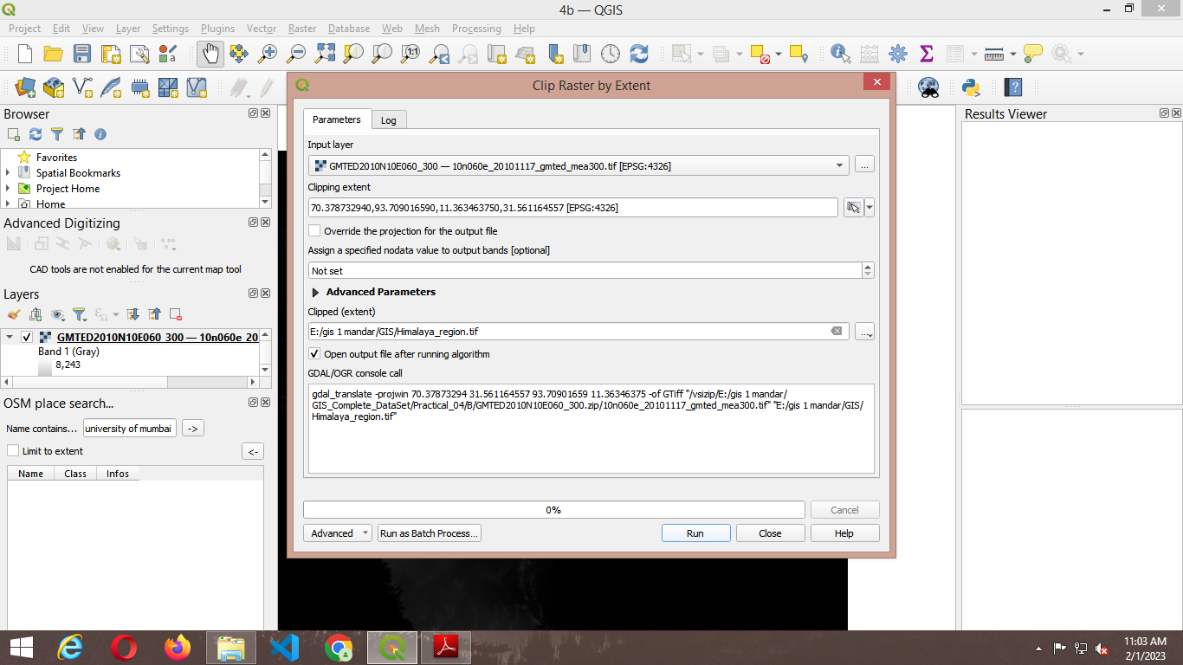

5) Press RUN.

➢ Deselect the original layer and keep the clipped one.

➢ The Clipped raster layer is representing altitude are from 103 Meters

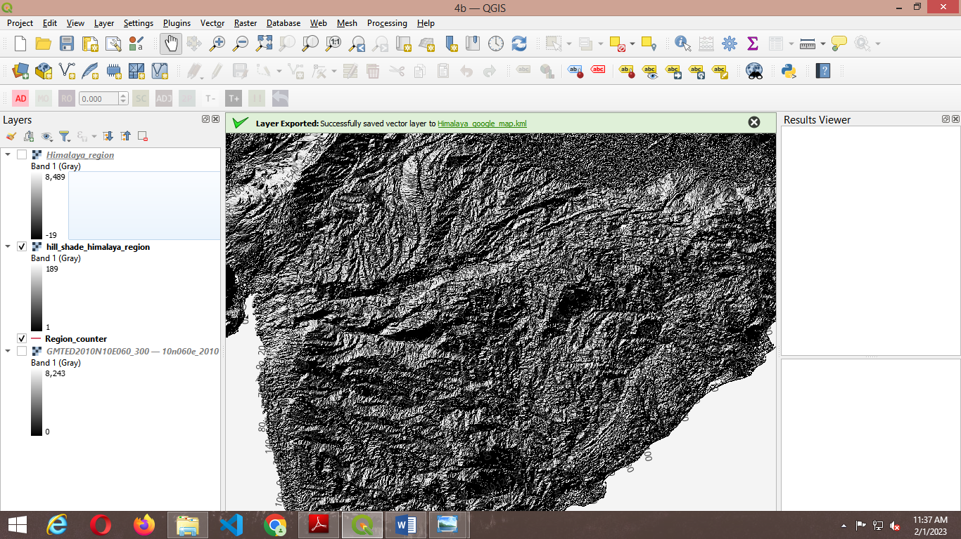

6) Counter lines are the lines on a map joining points of equal height above or below sea level. A **contour interval** in surveying is the vertical distance or the difference in the elevation between the two **contour** lines in a topographical map.

➢ To derive counter lines from given raster.

➢ Go to Raster → Extraction→ Contour



7) The Contour configuration window will appear

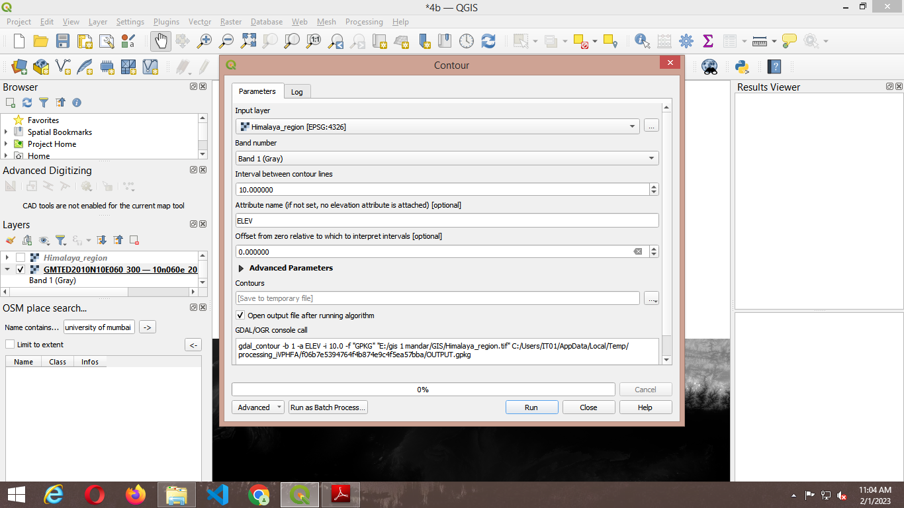

8) Select the input raster layer name. Set contour interval 100.00 meters, select the output file name & location and check the option to add output file to project after processing.

➢ Press “RUN”.

➢ The contour layer will appear like this

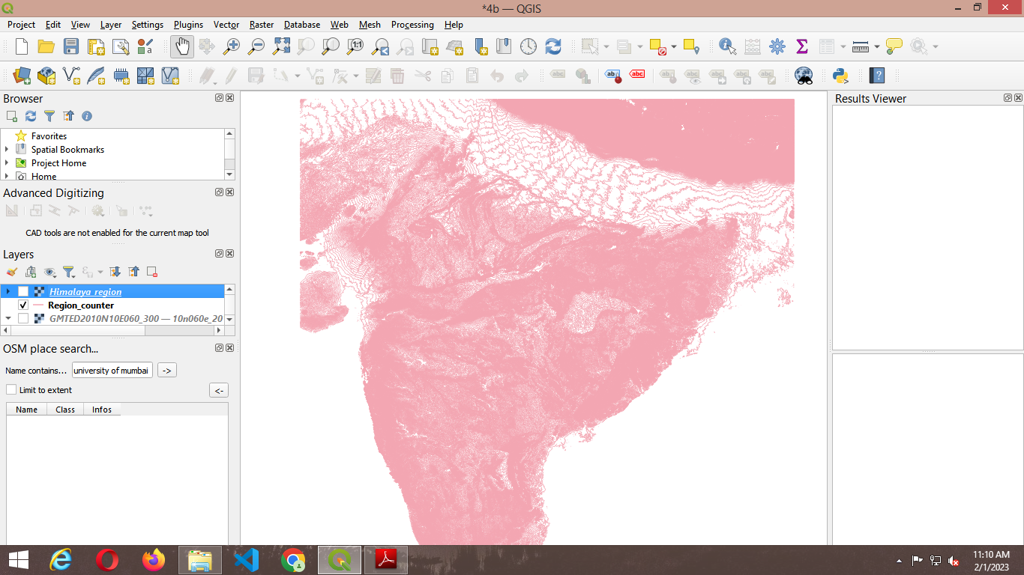

9) Label the layer using “ELEV” field and set appropriate symbols for line.

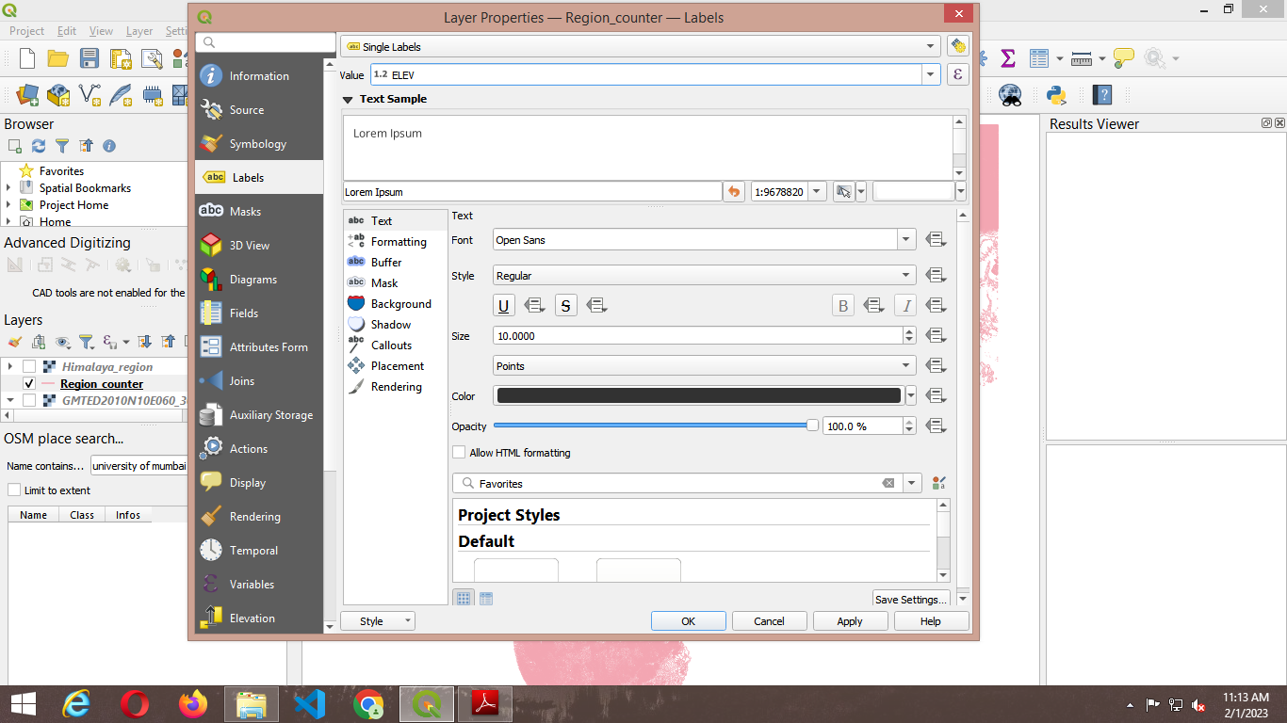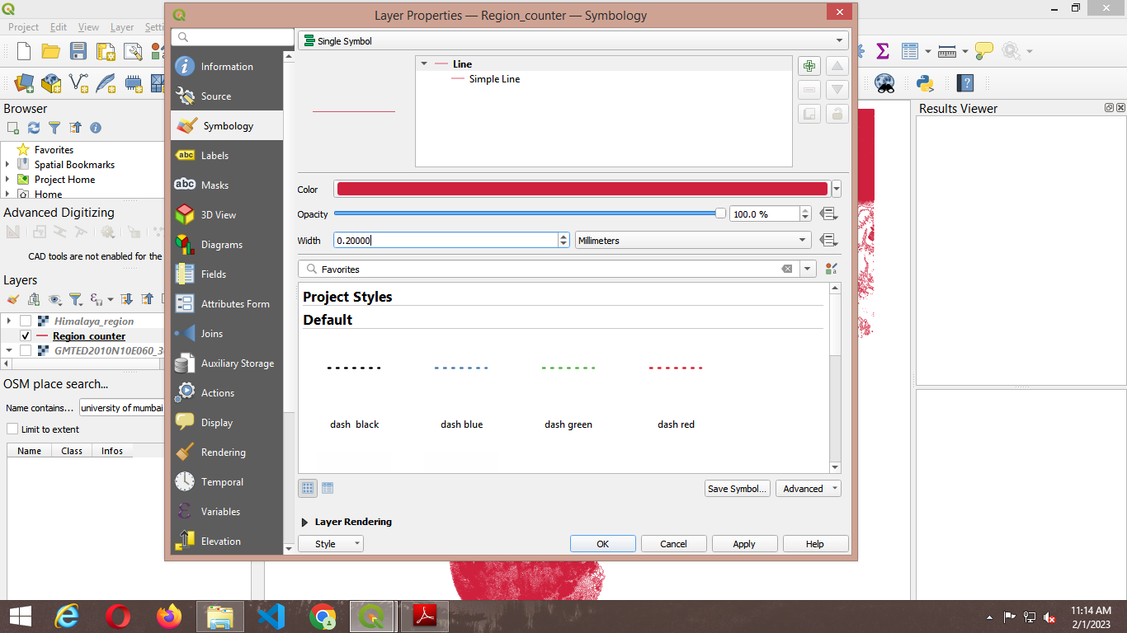

10) In the Layer panel right click on Contour Raster Layer and select “**Open Attribute table**”,

Arrange the table in descending order based on the value of “ELEV” column.

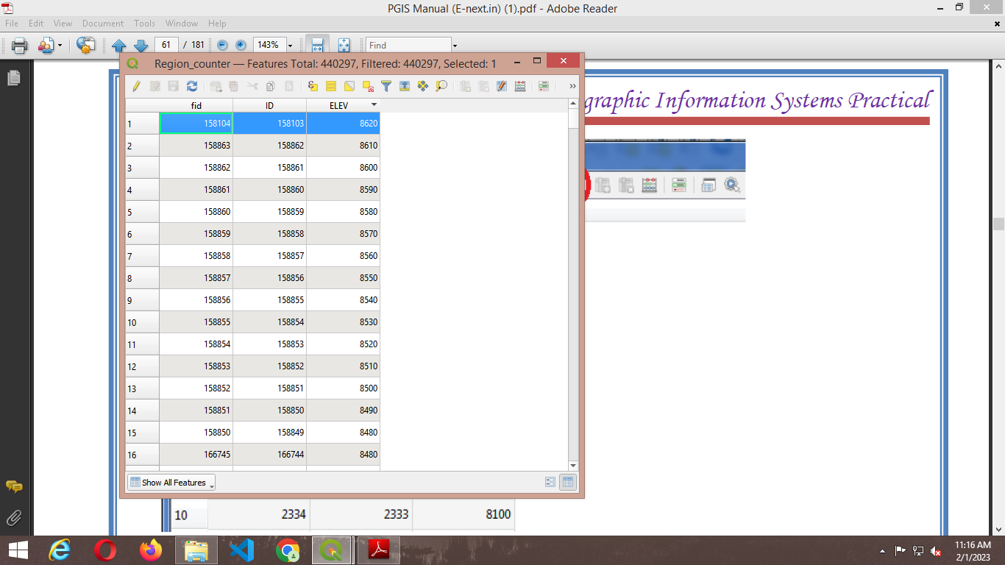

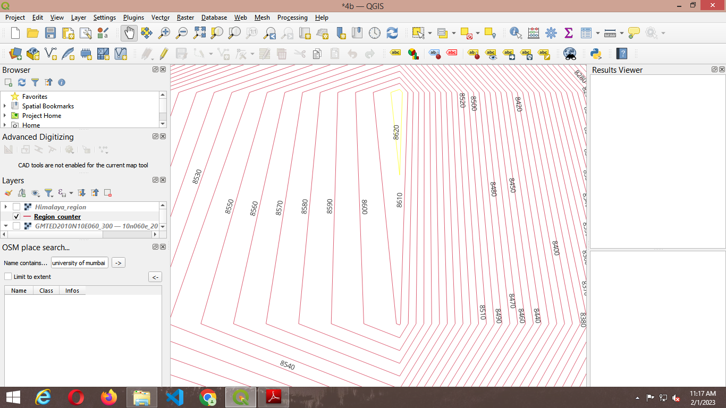

10) To verify the above contour files using Google Map

➢ Make a copy of Contour Layer, Go to Layer →Save As

➢ Select file format as “Keyhole Markup Language”, set file name, location and Layer Name.

➢ Also set CRS to WGS 84 EPSG:4326

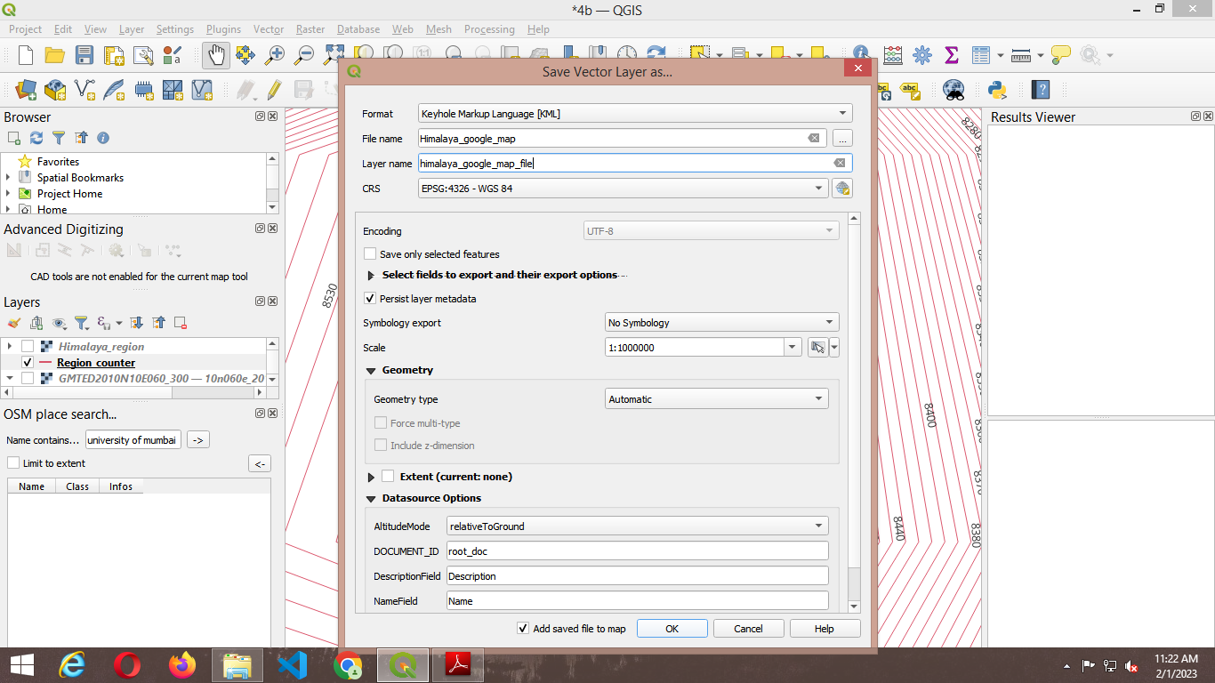

11) Go to the stored location on Hard Disk and open the “Himalayan_Google_Map_File.kml” with Google Map.\

12) For Hill Shade surface analysis

Go to Plugin 🡪Install Georeferencer GADL.

After successful installation of plugin Go to Raster → Analysis → Hill Shade

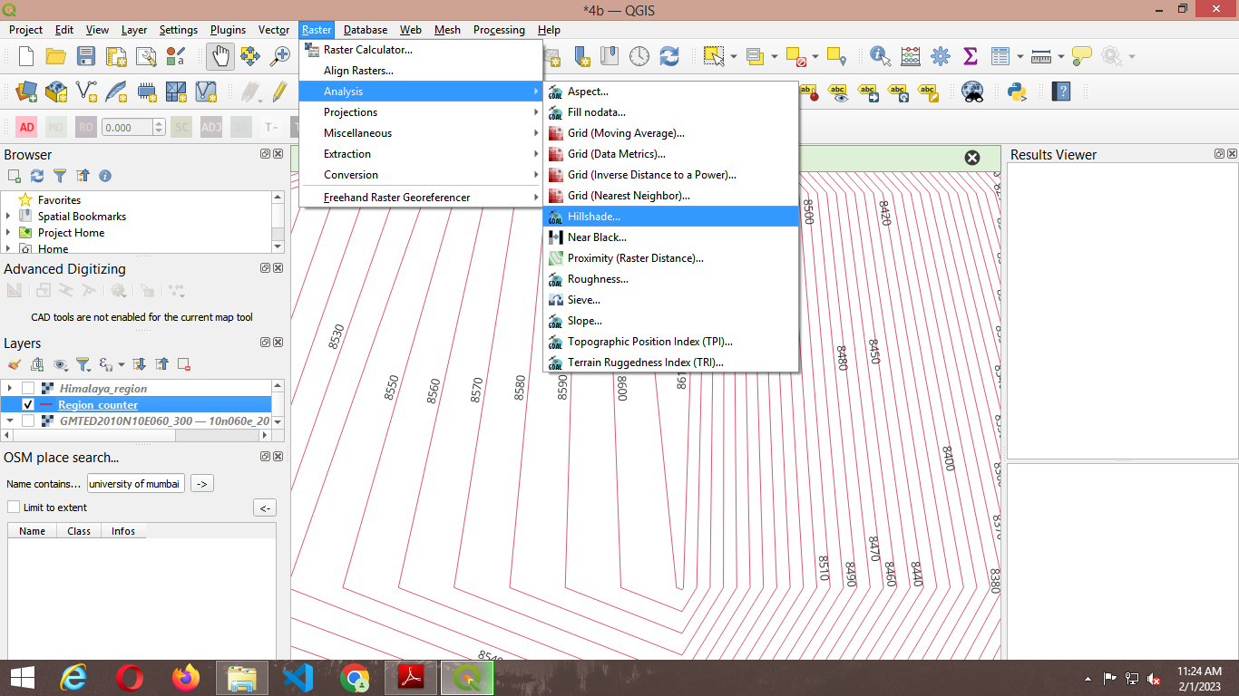

13) Select the input raster layer, select file name and location for storing Hill Shade output file.

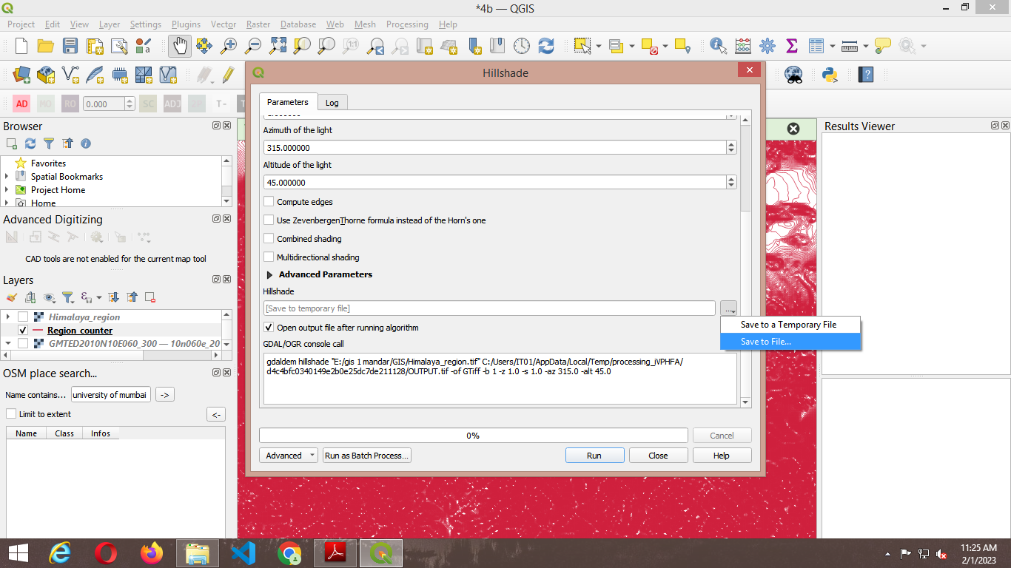

14) Press “RUN” and Close the Hill Shape Dialog window.

After Raster styling the Output will appear like this

